**Observational data: What Happened**

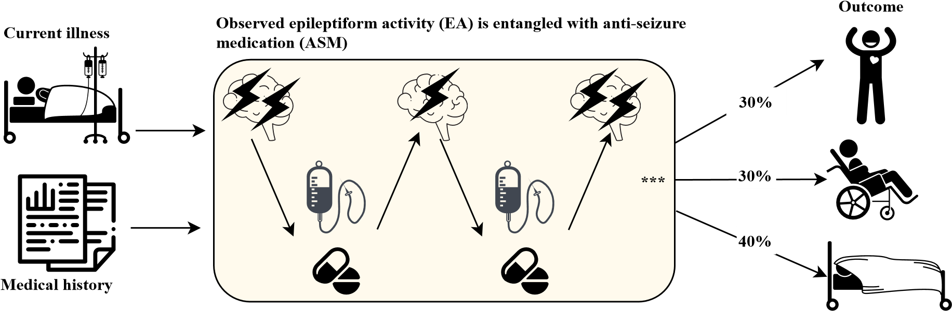

**Counterfactual: What would happen if the patient experienced different level of EA**

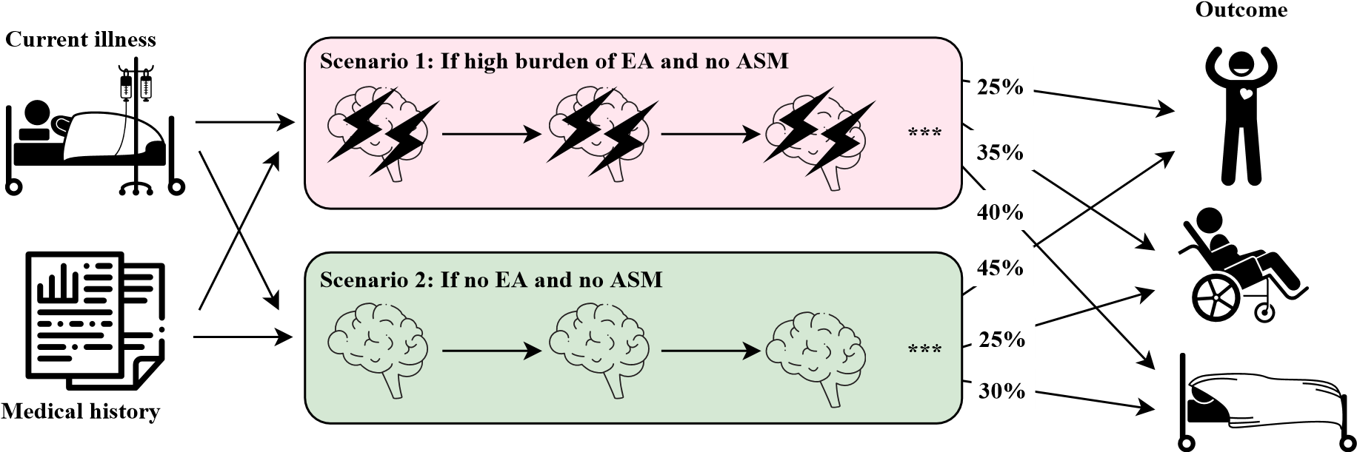

Figure 1: *Upper:* Illustration showing that observed epileptiform activity (EA) and treatment decision form a feedback loop, that is also influenced by current illness and medical history (left). The entire time-series of EA and ASM influence patient outcomes. Possible outcomes include return to normal health, disability, or death at the time of hospital discharge (right). *Lower:* Our goal is to estimate the effect of EA on patient outcomes. The effect is obtained by comparing the patient outcome across counterfactual scenarios. Scenario 1 is where every patient in this cohort had certain (high) level (or burden) of EA but no ASM is given; Scenario 2 is where every patient had no EA and also no ASM is could given. (Note that the probabilities given here are illustrative, and not taken from data.)

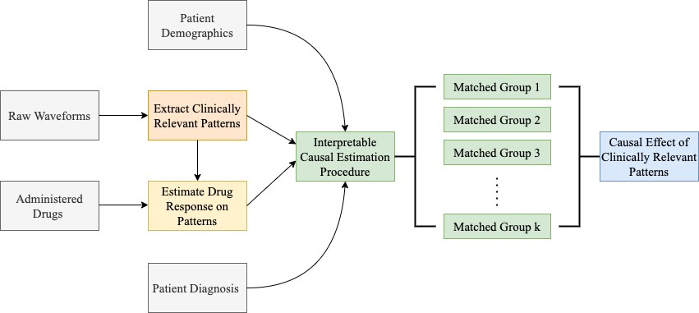

Figure 2: Flowchart demonstrating the working of our framework for interpretable inference of causal effects

(

a

)

*Pr*

[

*Y*

(

*E*

max

=

*e,*

*W*

*i,t*

=0)=1]

(

b

)

*Pr*

[

*Y*

(

*E*

mean

=

*e,*

*W*

*i,t*

=0)=1]

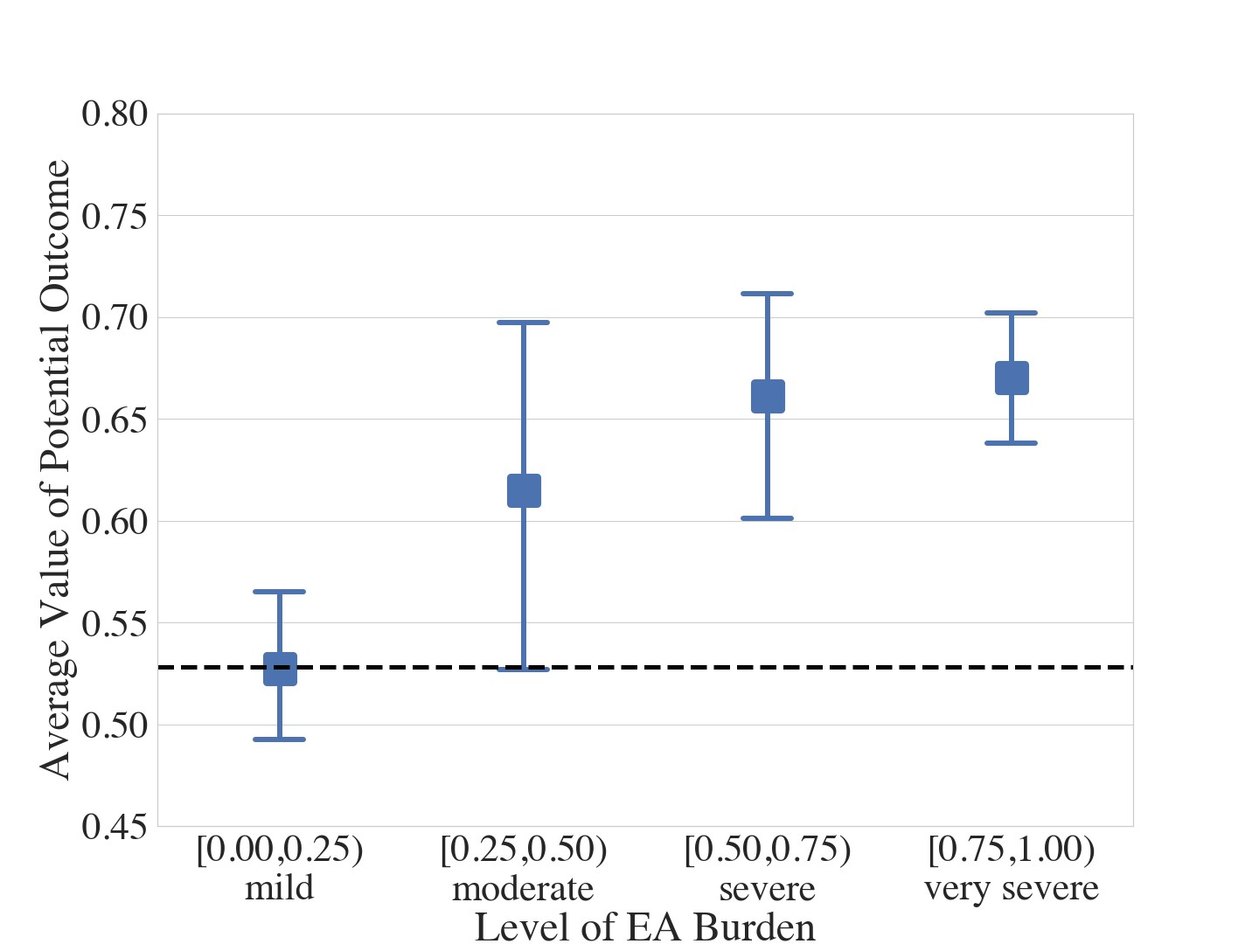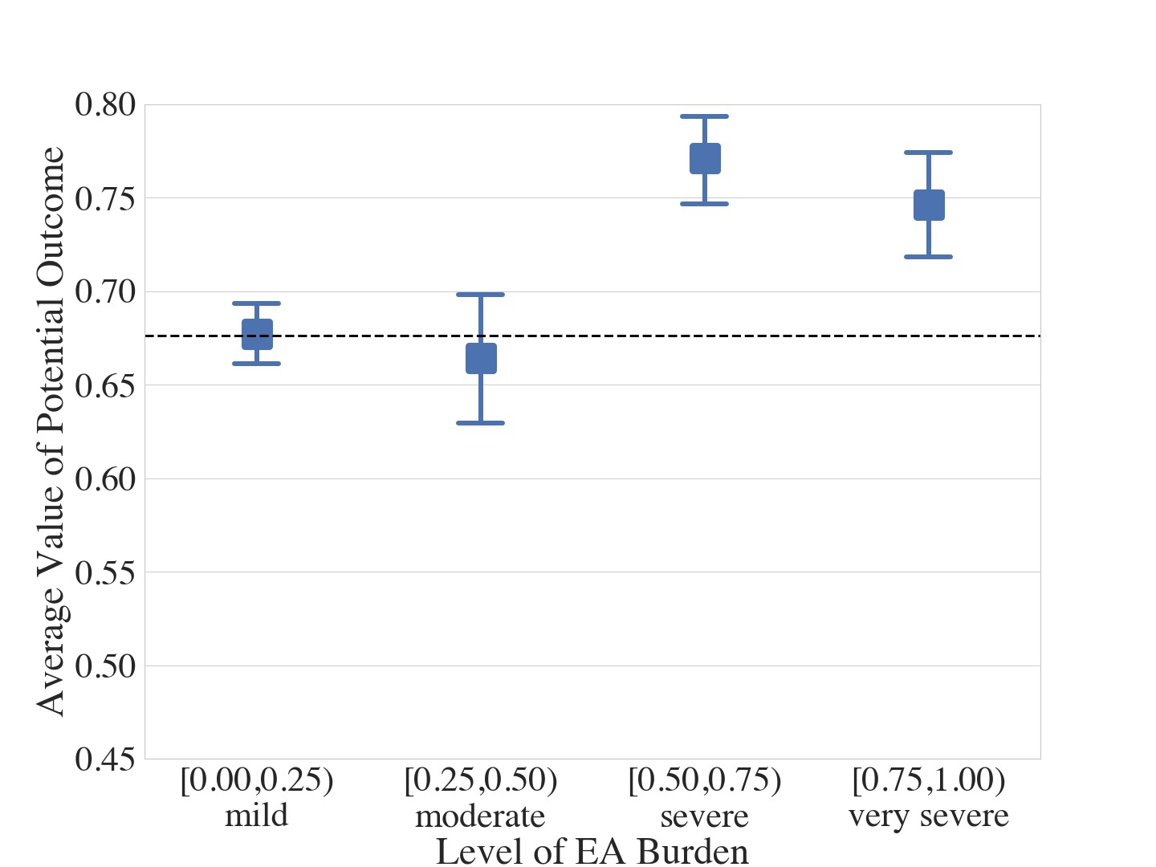

Figure 3: The probability of a poor outcome mRS for either Mild, Moderate, Severe, or Very Severe EA burden. EA Burden is quantified as (Left): Maximum EA in a 6-hour moving average window; (Right): Mean EA in a 6-hour moving average window. In both scenarios, an increase in EA burden leads to a worse outcome for the patient. Outcome worsens monotonically for *E*max, whereas for *E*mean, there is a jump at approximately 0.5. In both plots the horizontal line represents the baseline median average potential outcome for mild case.

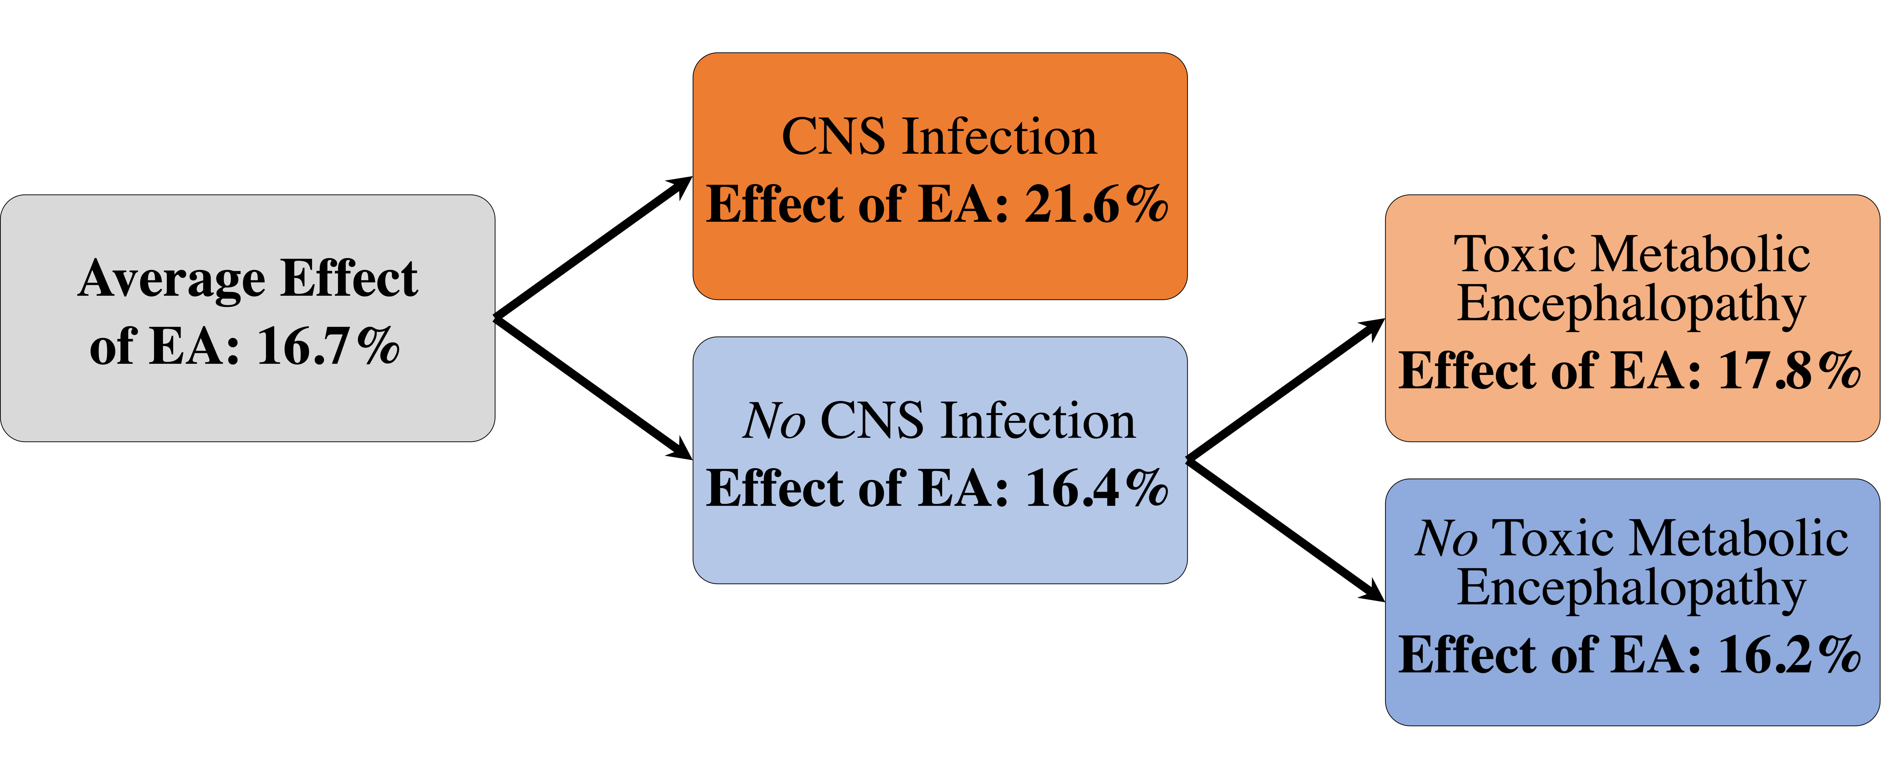

1. Recursive partitioning of covariate space and respective relative effects of very severe EA

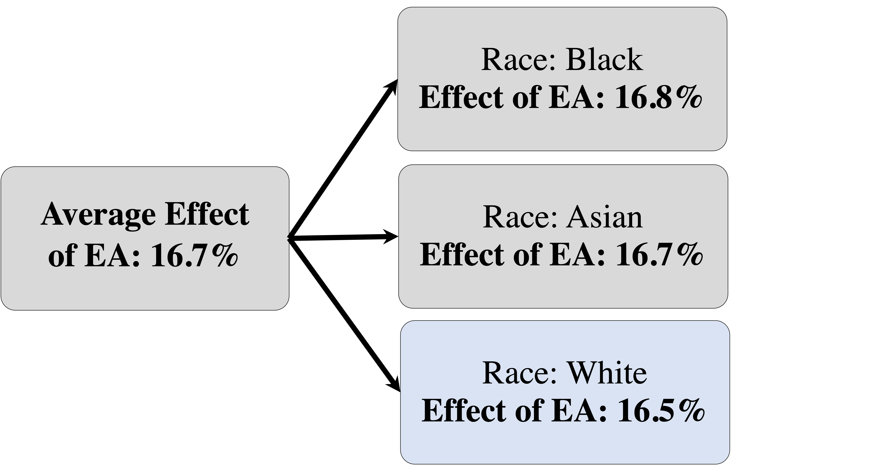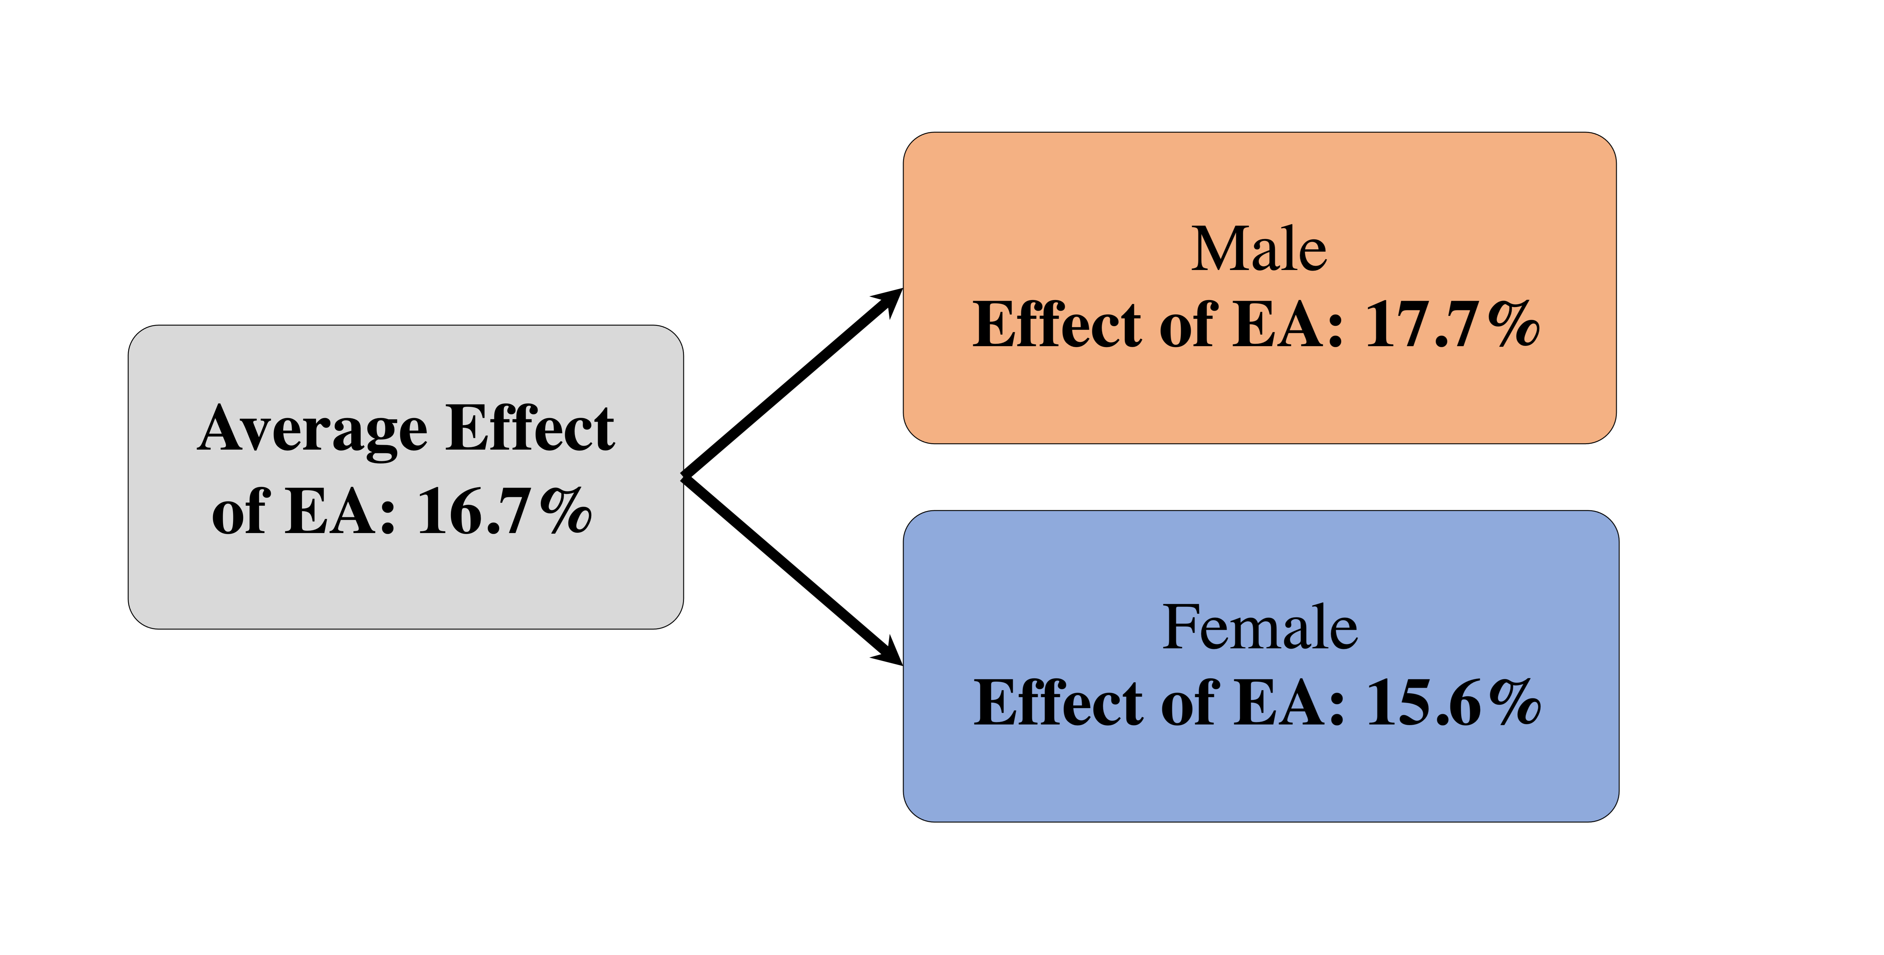

1. Relative effect on patients from different races (c) Relative effect on male and female patients

Figure 4: Heterogeneity in the average effect of EA, stratified by: (a) Recursive partitioning on the entire covariate space using Gini splitting to find the most important splits; (b) Partitions the space according patients’ race. The remaining race classes (other, undisclosed, and missing) are rare representing 0*.*5%, 5%, and 8*.*4% of the total population. (c) Partitions the space across to patients’ gender. Orange coloring in the boxes implies that the subgroup experiences a larger average estimated causal effect of EA on neurologic outcomes than the cohort mean, and blue implies a smaller causal effect. Subgroups in orange fare worse because of a higher EA burden.

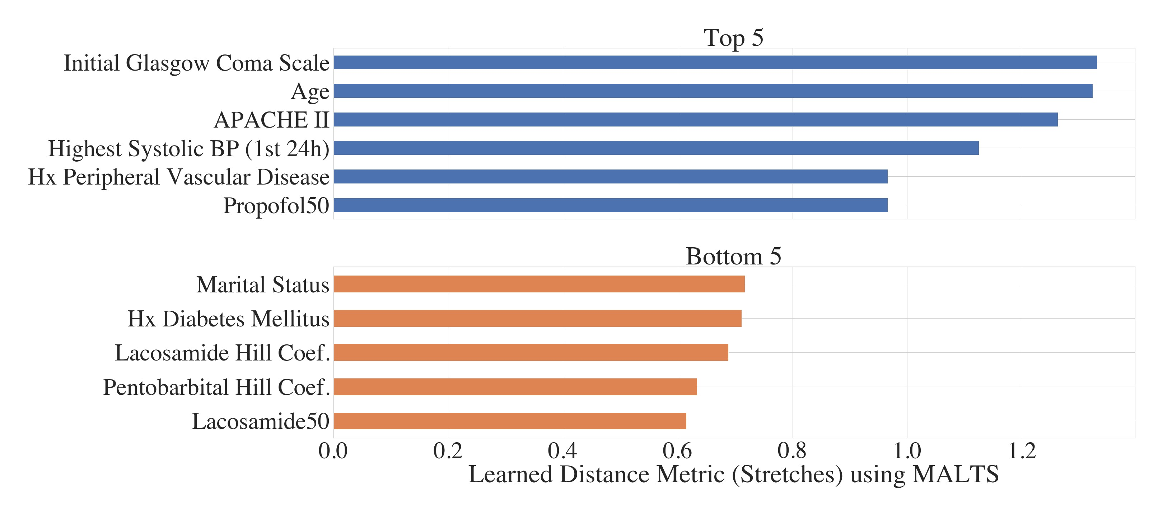Figure 5: The top and bottom 5 variables, based on the average stretching weights in MALTS, when we are studying the effect of the maximum EA burden *E*max. BP = blood pressure; Coef = coefficient.; Lacosamide50 = concentration of Lacosamide that reduces EA burden by 50%; Propofol50 = concentration of propofol that reduces EA burden by 50%; Hx = History.

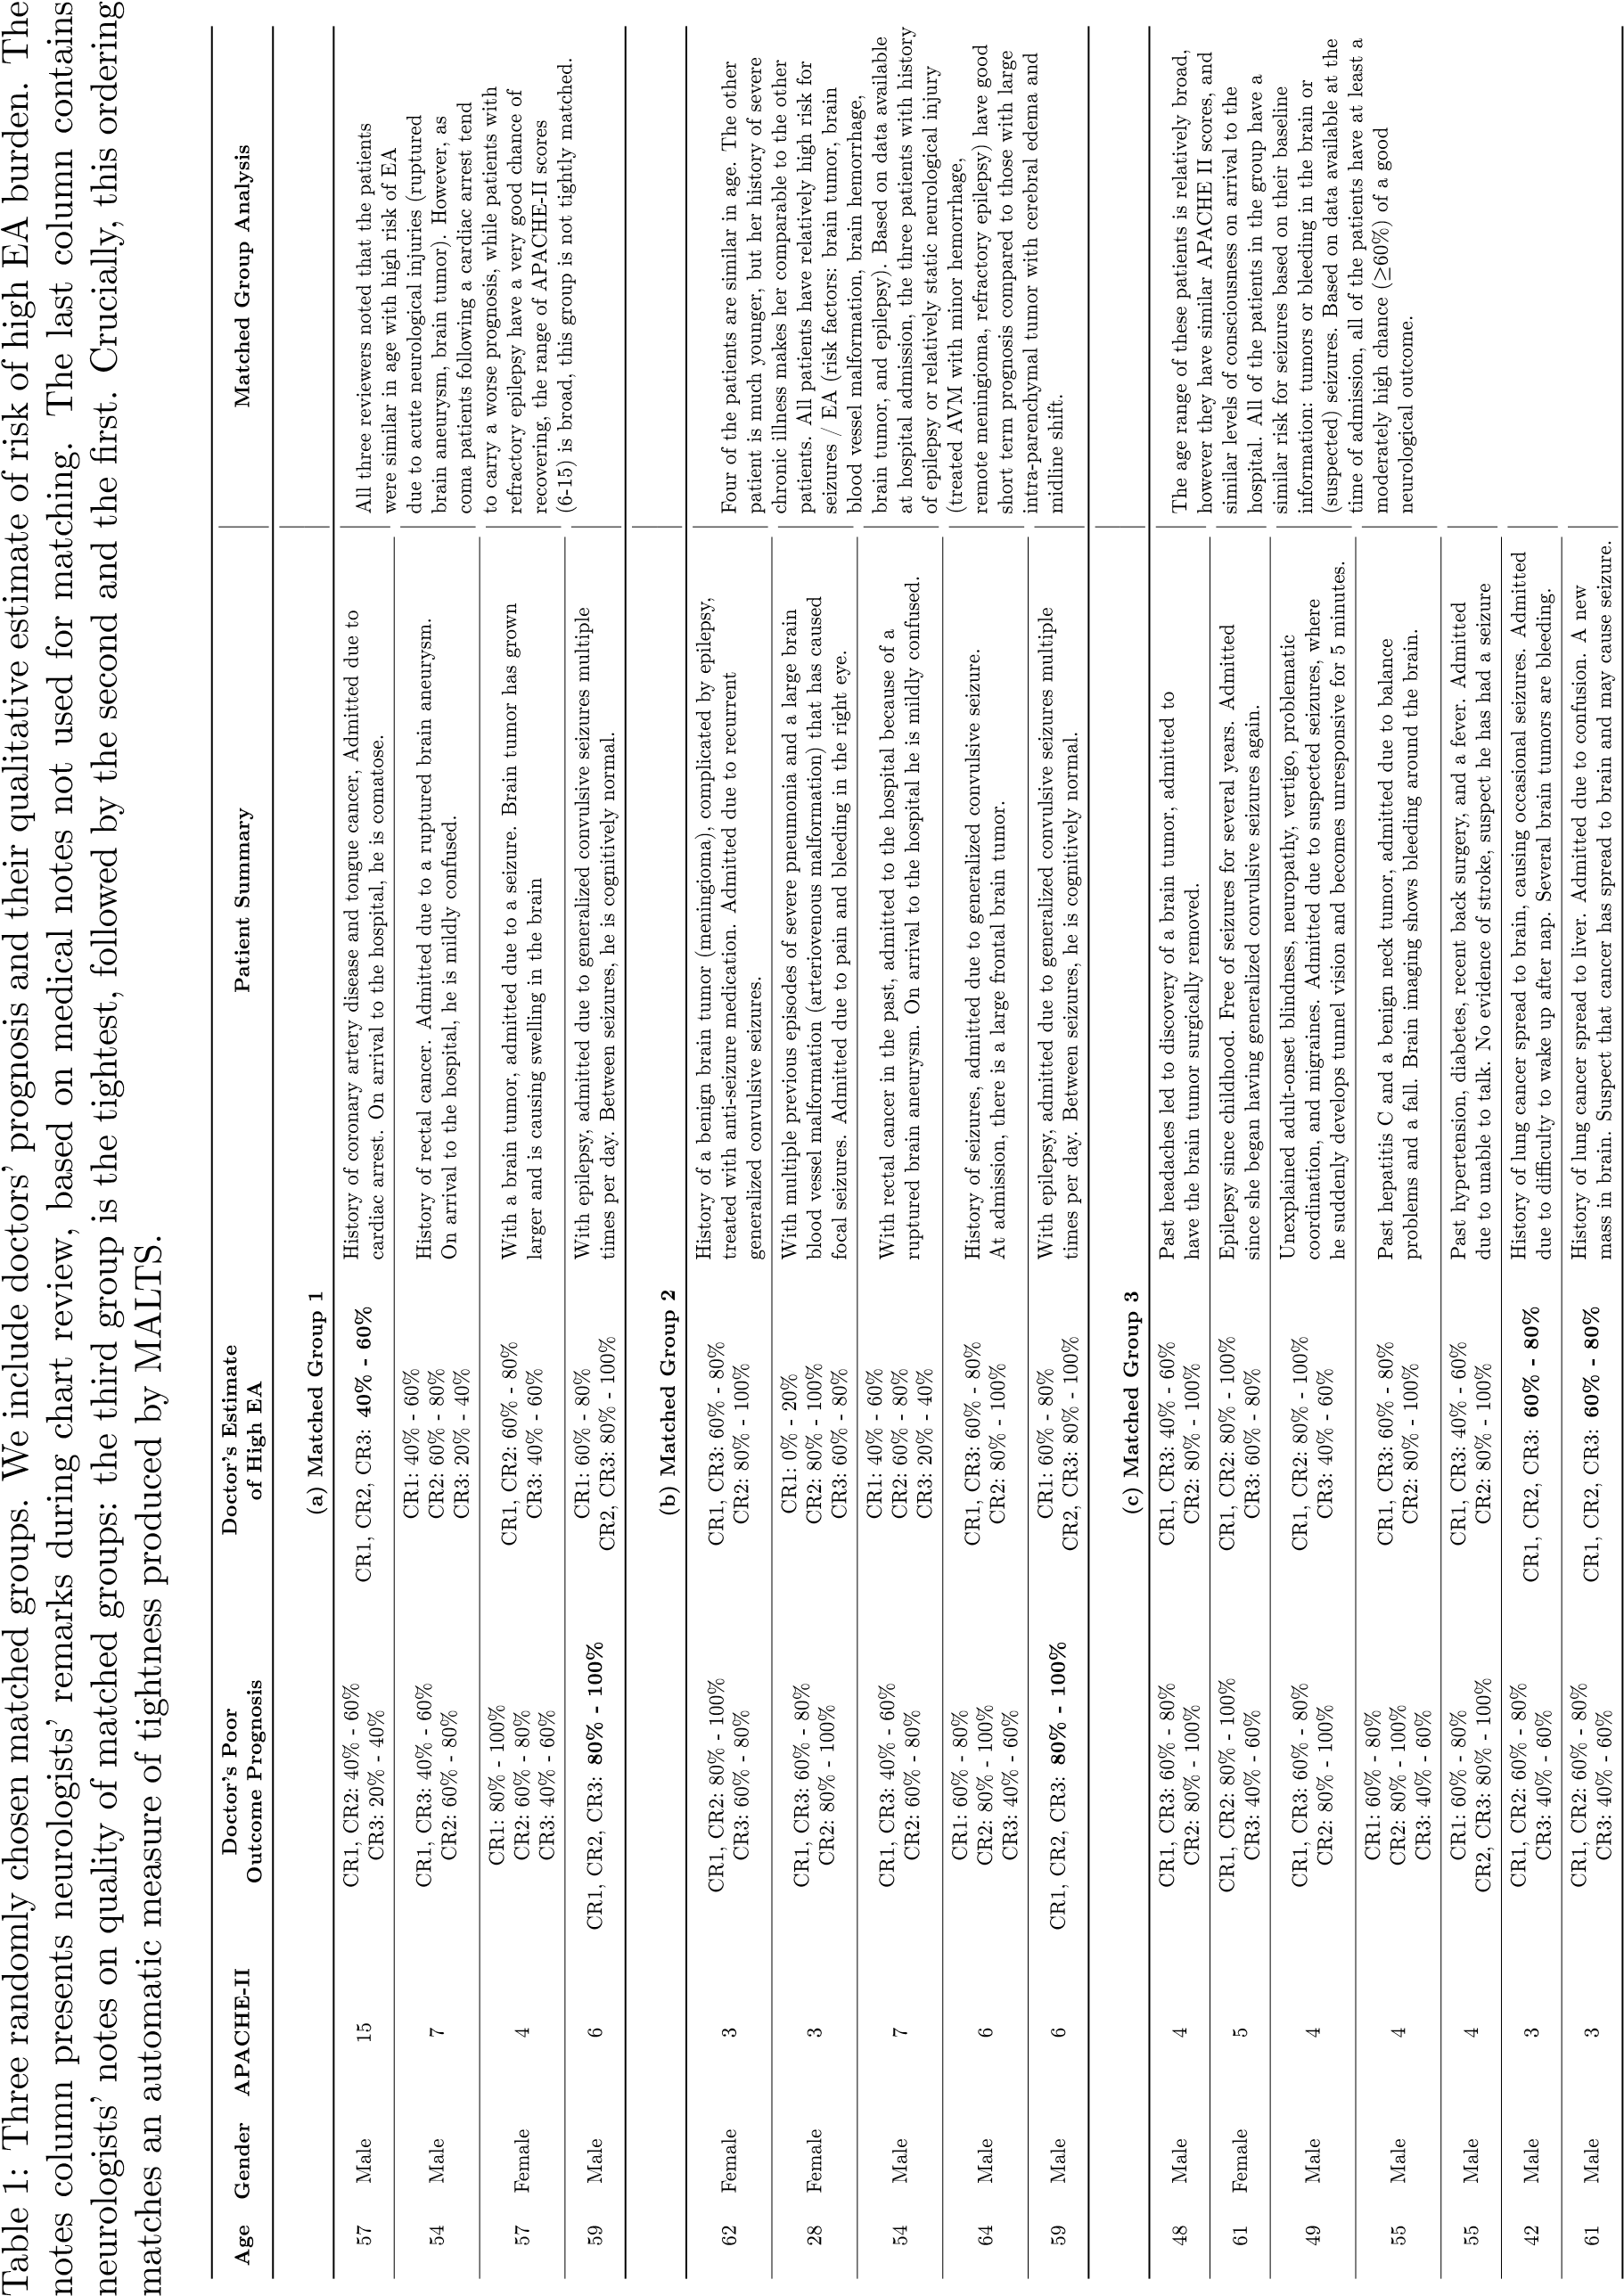

# **Appendix A Data**

Table 2: Summary Statistics of Pre-admission Covariates (C)

|  |  |
| --- | --- |
| Variable | Value |
| Age, year, median (IQR) | 61 (48 – 73) |
| Male gender, n (%) | 475 (47.7%) |
| Race |  |
| Asian, n (%) | 33 (3.3%) |
| Black / African American, n (%) | 72 (7.2%) |
| White / Caucasian, n (%) | 751 (75.5%) |
| Other, n (%) | 50 (5.0%) |
| Unavailable / Declined, n (%) | 84 (8.4%) |
| Married, n (%) | 500 (50.3%) |
| Premorbid mRS before admission, median (IQR) | 0 (0 – 3) |
| APACHE II in first 24h, median (IQR) | 19 (11 – 25) |
| Initial GCS, median (IQR) | 11 (6 – 15) |
| Initial GCS is with intubation, n (%) | 415 (41.7%) |
| Worst GCS in first 24h, median (IQR) | 8 (3 – 14) |
| Worst GCS in first 24h is with intubation, n (%) | 511 (51.4%) |
| Admitted due to surgery, n (%) | 168 (16.9%) |
| Cardiac arrest at admission, n (%) | 79 (7.9%) |
| Seizure at presentation, n (%) | 228 (22.9%) |
| Acute SDH at admission, n (%) | 146 (14.7%) |
| Take anti-epileptic drugs outside hospital, n (%) | 123 (12.4%) |
| Highest heart rate in first 24h, /min, median (IQR) | 92 (80 – 107) |

|  |  |
| --- | --- |
| Lowest heart rate in first 24h, /min, median (IQR) | 71 (60 – 84) |
| Highest systolic BP in first 24h, mmHg, median (IQR) | 153 (136 – 176) |
| Lowest systolic BP in first 24h, mmHg, median (IQR) | 116 (100 – 134) |
| Highest diastolic BP in first 24h, mmHg, median (IQR) | 84 (72 – 95) |
| Lowest diastolic BP in first 24h, mmHg, median (IQR) | 61 (54 – 72) |
| Mechanical ventilation on the first day of EEG, n (%) | 572 (57.5%) |
| Systolic BP on the first day of EEG, mmHg, median (IQR) | 148 (130 – 170) |
| GCS on the first day of EEG, median (IQR) | 8 (5 – 13) |
| History |  |
| Stroke, n (%) | 192 (19.3%) |
| Hypertension, n (%) | 525 (52.8%) |
| Seizure or epilepsy, n (%) | 182 (18.3%) |
| Brain surgery, n (%) | 109 (11.0%) |
| Chronic kidney disorder, n (%) | 112 (11.3%) |
| Coronary artery disease and myocardial infarction, n (%) | 160 (16.1%) |
| Congestive heart failure, n (%) | 90 (9.0%) |
| Diabetes mellitus, n (%) | 201 (20.2%) |
| Hypersensitivity lung disease, n (%) | 296 (29.7%) |
| Peptic ulcer disease, n (%) | 50 (5.0%) |
| Liver failure, n (%) | 46 (4.6%) |
| Smoking, n (%) | 461 (46.3%) |
| Alcohol abuse, n (%) | 231 (23.2%) |
| Substance abuse, n (%) | 119 (12.0%) |
| Cancer (except central nervous system), n (%) | 180 (18.1%) |
| Central nervous system cancer, n (%) | 85 (8.5%) |

|  |  |
| --- | --- |
| Peripheral vascular disease, n (%) | 41 (4.1%) |
| Dementia, n (%) | 45 (4.5%) |
| Chronic obstructive pulmonary disease or asthma, n (%) | 139 (14.0%) |
| Leukemia or lymphoma, n (%) | 22 (2.2%) |
| AIDS, n (%) | 12 (1.2%) |
| Connective tissue disease, n (%) | 47 (4.7%) |
| Primary diagnosis |  |
| Septic shock, n (%) | 131 (13.2%) |
| Ischemic stroke, n (%) | 85 (8.5%) |
| Hemorrhagic stroke, n (%) | 163 (16.4%) |
| Subarachnoid hemorrhage (SAH), n (%) | 188 (18.9%) |
| Subdural hematoma (SDH), n (%) | 94 (9.4%) |
| SDH or other traumatic brain injury including SAH, n (%) | 52 (5.2%) |
| Traumatic brain injury including SAH, n (%) | 21 (2.1%) |
| Seizure/status epilepticus, n (%) | 258 (25.9%) |
| Brain tumor, n (%) | 113 (11.4%) |
| CNS infection, n (%) | 64 (6.4%) |
| Ischemic encephalopathy or Anoxic brain injury, n (%) | 72 (7.2%) |
| Toxic metabolic encephalopathy, n (%) | 104 (10.5%) |
| Primary psychiatric disorder, n (%) | 35 (3.5%) |
| Structural-degenerative diseases, n (%) | 35 (3.5%) |
| Spell, n (%) | 5 (0.5%) |
| Respiratory disorders, n (%) | 304 (30.6%) |
| Cardiovascular disorders, n (%) | 153 (15.4%) |
| Kidney failure, n (%) | 65 (6.5%) |
| Liver disorder, n (%) | 30 (3.0%) |
| Gastrointestinal disorder, n (%) | 18 (1.8%) |
| Genitourinary disorder, n (%) | 34 (3.4%) |
| Endocrine emergency, n (%) | 28 (2.8%) |
| Non-head trauma, n (%) | 13 (1.3%) |
| Malignancy, n (%) | 65 (6.5%) |
| Primary hematological disorder, n (%) | 24 (2.4%) |

Table 3: Half-life for the anti-seizure medications used in the PD modeling.

|  |  |
| --- | --- |
| Drug | Half Life |
| Propofol | 20 minutes |
| Midazolam | 2.5 hours |
| Levetiracetam | 8 hours |
| Lacosamide | 11 hours |
| Phenobarbital | 79 hours |
| Valproate | 16 hours |

Table 4: Binning of EA burden into 4 levels

|  |  |  |  |  |
| --- | --- | --- | --- | --- |
| EA Burden | Mild | Moderate | Severe | Very Severe |
| *E*max or *E*mean | 0 to 0.25 | 0.25 to 0.5 | 0.5 to 0.75 | 0.75 to 1 |
| Number of patients with *E*max | 272 | 130 | 107 | 451 |
| Number of patients with *E*mean | 661 | 134 | 88 | 77 |

Table 5: Primary table of notations

|  |  |
| --- | --- |
| Symbol | Description |
| *Ci* | Vector pre-admission covariates such as age, vital signs, and medical history |
| *Wi,t* | Sequence of ASMs administered during their stay in the hospital |
| *Di,j,t* | Blood concentration of ASM *j* at time *t* |
| *Ei,*max | Worst 6 hour epoch of EA burden within a 24 hour period |
| *Ei,*mean | Average amount of time a patient experiences EA in a 24 hour period |
| *Yi* | Binarized post-discharge outcome (0 if mRS ≤ 3 and 1 if mRS *>* 3) |
| *Yi*(*e,w*) | Potential outcome if EA burden is *e* and total ASMs administered is *w* |

Figure 6: The overall analysis framework, consisting of three parts (indicated by different colors): EA burden computation, individual PK/PD modeling, and MALTS matching and effect estimation.

Figure 7: Hill coefficient vs*. ED*50 for the six drugs. Each point is a patient. The non-responsive patients with Hill coefficient of zero are highlighted.

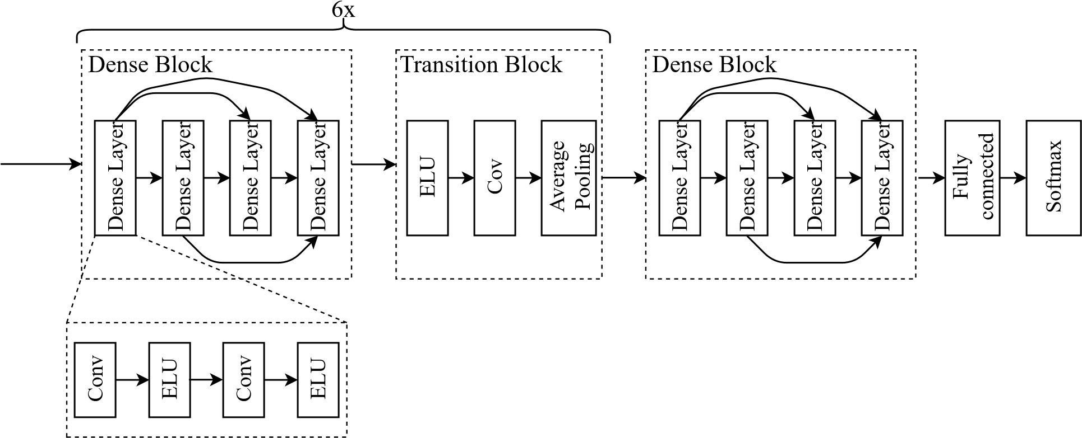

Figure 8: Structure of the DenseNet for automatic EA labeling.

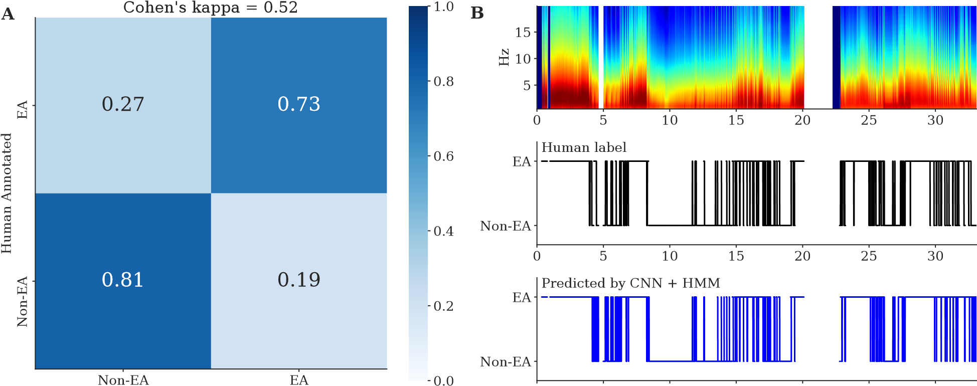

CNN Predicted 0 5 10 15 20 25 30

Time (hour)

Figure 9: (A) Confusion matrix for the CNN prediction vs*.* human annotation, where each row represents the fraction of 2-second segments classified into EA (seizure/GPD/LPD/LRDA) or Non-EA (GRDA/other/artifact). The overall Cohen’s kappa is 0.52. (B) The top panel shows the spectrogram of the EEG signal of one example subject; the middle panel shows EA patterns annotated by a human expert for every 2 second interval. The bottom panel shows the EA pattern annotated by the CNN followed by HMM smoothing.

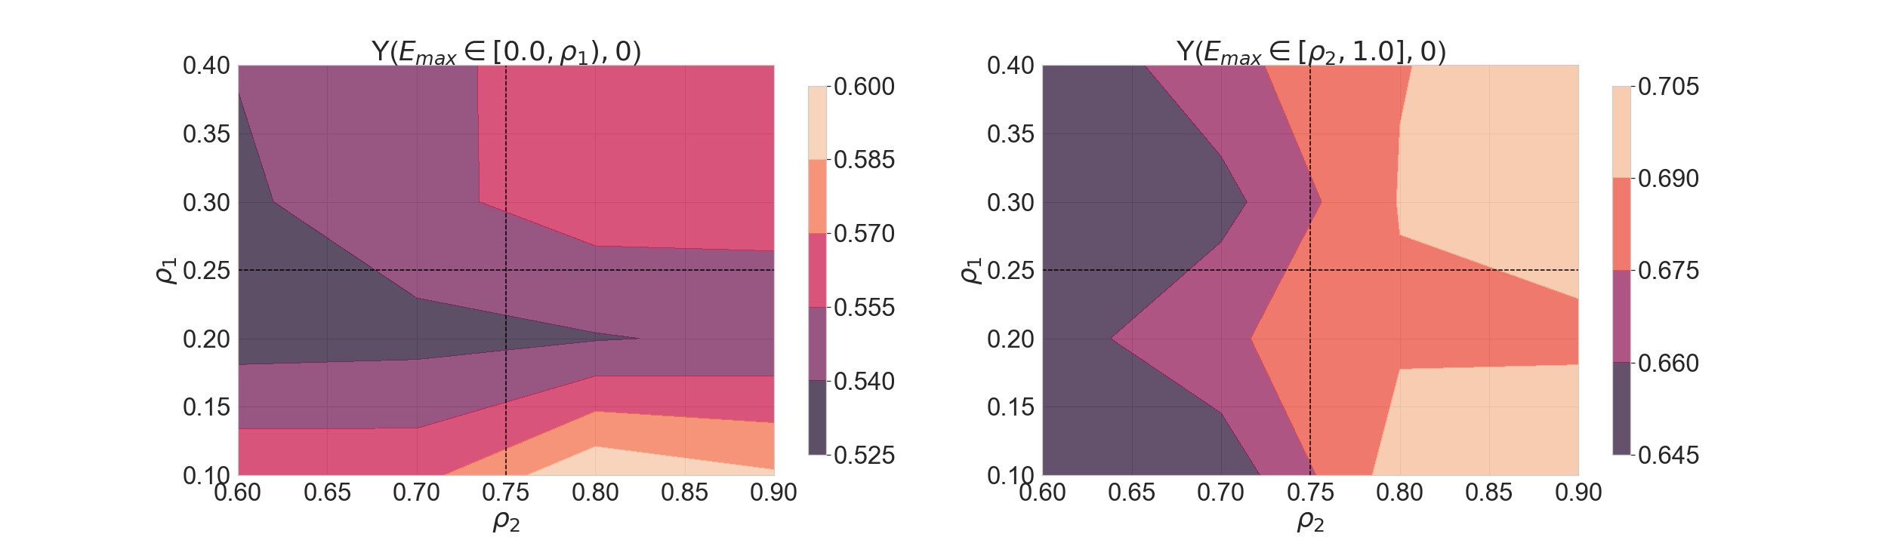

Figure 10: Sensitivity to quantization of EA burden into four levels. *ρ*1 is the boundary between mild and moderate EA burden and *ρ*2 is the boundary between severe and very severe EA burden. The contour plot shows estimated average potential outcomes – *Y* ([0*,ρ*1)*,*0) and *Y* ([*ρ*2*,*1]*,*0) – for a range of *ρ*1 and *ρ*2. We find that the gradient of contours is more or less flat and the estimates do not change by a large amount as the sensitivity parameters change.

0

1

2

3

4

5

6

Discharge mRS

0.00

0.05

0.10

0.15

0.20

0.25

0.30

0.35

0.40

Density

p = 0.32

**A**

Have EEG data (n = 1968)

No EEG data (n = 17)

0

1

2

3

4

5

6

Discharge mRS

0.00

0.05

0.10

0.15

0.20

0.25

0.30

0.35

0.40

p = 0.39

**B**

Have EEG and drug (n = 1514)

No EEG or drug (n = 471)

Figure 11: (A) The histogram of patients’ discharge mRS (possible values are 0,1,2,3,4,5,6). The two subsets that are compared are patients who have EEG data (n = 1968) vs. patients who do not have EEG data (n = 17). To make the subsets comparison, the y-axis shows the density instead of the count. The p-value is from the Mann-Whitney U test of the two subsets. (B) Similar to A, but for patients who have EEG and drug data (n = 1514) vs. patients who do not have EEG or drug data (n = 471).

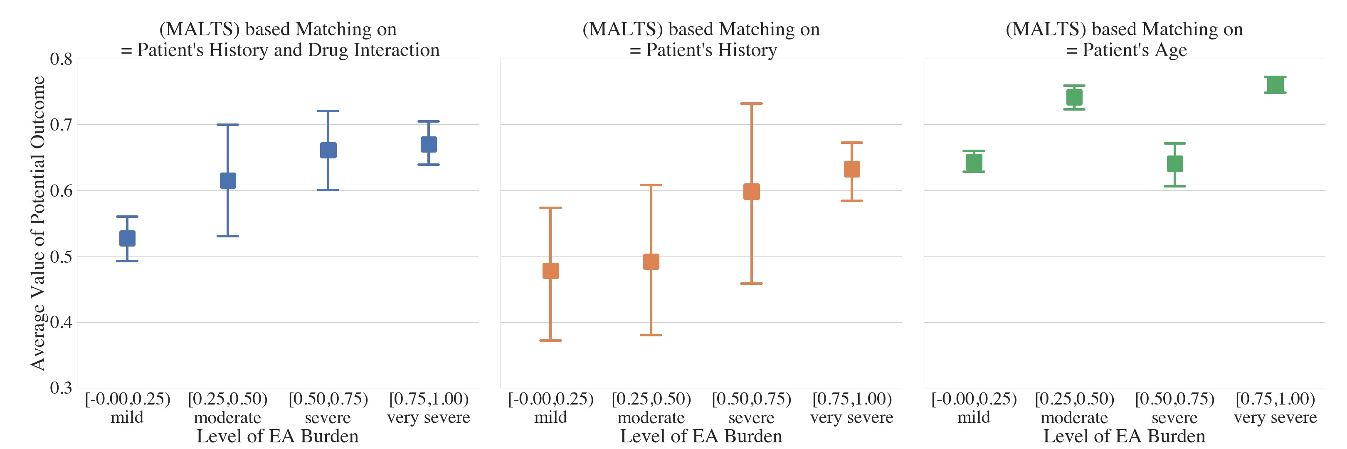

Figure 12: Estimated average potential outcome for different levels of *E*max by matching on (left) all preadmission covariates and PD parameters, (middle) all pre-admission covariates, and (right) only age of the patients.

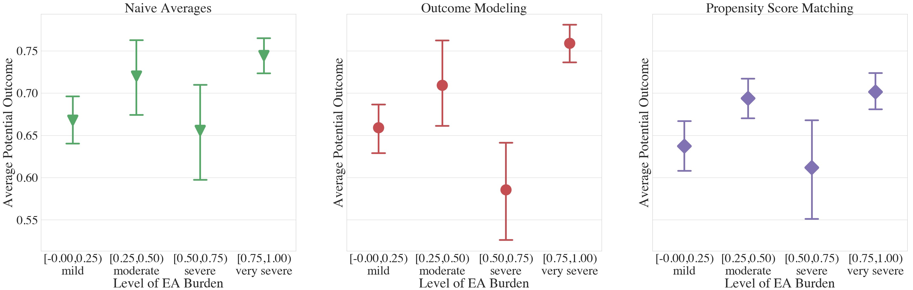

Figure 13: Estimated average potential outcomes computed using (left) Naive Average approach, (middle) Outcome modeling approach, and (right) Propensity Score matching.

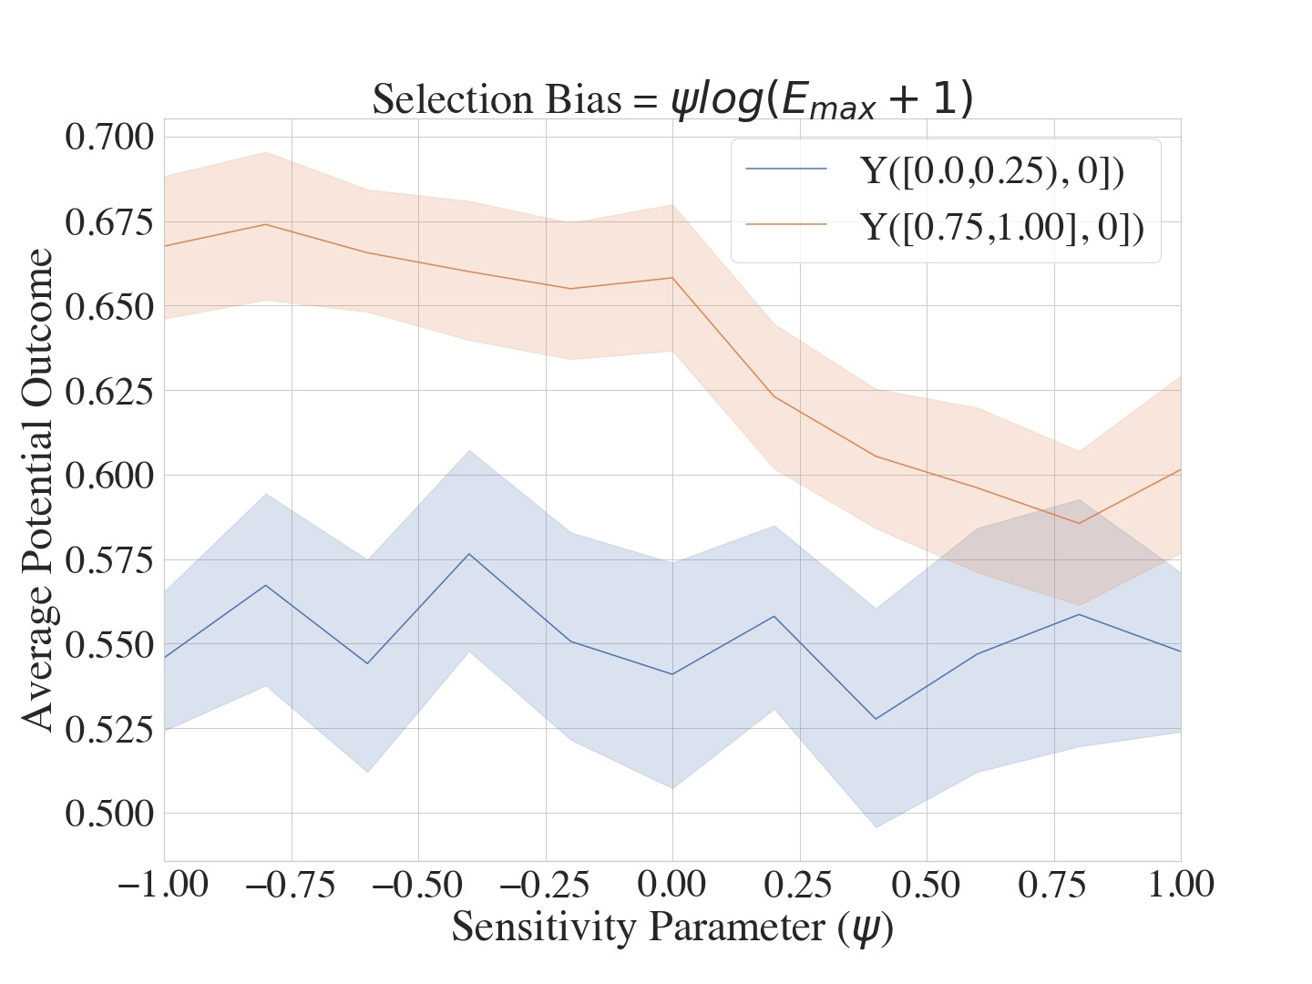

Figure 14: Sensitivity to unobserved confounding The results show that even at very high levels of selection bias, the effect of EA burden is not lost, indicating a degree of robustness in our results.